Sensitivity analyses diagnostics

**Contents**

Basic robustness to assumptions (e.g. estimability/identifiability of parameters) [Peter, Ian, Jon]

Age-structured production model [Felipe, name2, …]

# Basic robustness to assumptions (e.g. estimability/identifiability of parameters) [Peter, Ian, Jon]

**Name**:

**Goal**: The goal is to evaluate the ability of the available data to estimate parameters of key processes. While generally US assessments are data-rich, there may not be sufficient information to estimate specific processes. Evaluating the identifiability of parameters is an important step in assessment model development. The robustness of a model to assumptions can be tested by computing the effects of changes in inputs on model prediction, or sensitivity analyses.

**Description:**

* This section is closely related to goodness-of-fit and model sensitivity sections
* Integrated stock assessment models require accounting for many biological processes (e.g. stock-recruit relationships, growth, movement). In some cases, parameters related to each of these processes cannot be estimated from the data because there is insufficient information or a lack of contrast in stock size through time.

**How to:**

* Conduct likelihood profiles to identify the data sets contain information on a particular parameter. Hopefully, there is general agreement among different data sets (e.g. between age compositions and length compositions). Data weighting may be necessary if data sets have conflicting information.
* One can evaluate the robustness of an integrated model by systematically analyzing the impacts of changes in model inputs along axes of uncertainty. While situation dependent, sensitivity analyses may be related to:
  + Spatial structure
  + Change points in time
  + Population structure
  + Stock-recruitment resilience
  + Growth
  + Natural mortality
  + Density-dependent or -independent processes
  + Process error
  + Observation error
  + Maturation
* For changes that are represented through parameters (such as natural mortality or stock-recruit steepness), run a likelihood profile over individual parameters to the amount of information in each data set about parameters of interest and explore conflicts among data sets. Note that univariate likelihood profiles may not account for correlation among parameter estimates and it is recommended to evaluate the estimated correlation matrix for confounded parameters with high correlations.
* For structural assumptions, like alternative spatial structure, or alternative data weighting methods, test the sensitivity of the model results to alternative assumptions.

**Example (include figures here):**

Pacific sardine has a relatively short life span, and as a result the assessment model covers a relatively narrow time period (2005-2019). Historically, steepness has been fixed as it is not estimable from the data. The figure below shows a likelihood profile of steepness. Notably, changing the value of steepness does not significantly improve (or degrade) model fits to the age composition, survey indices of abundance, nor catch data. This finding was justification for continuing to fix the steepness value in the assessment.

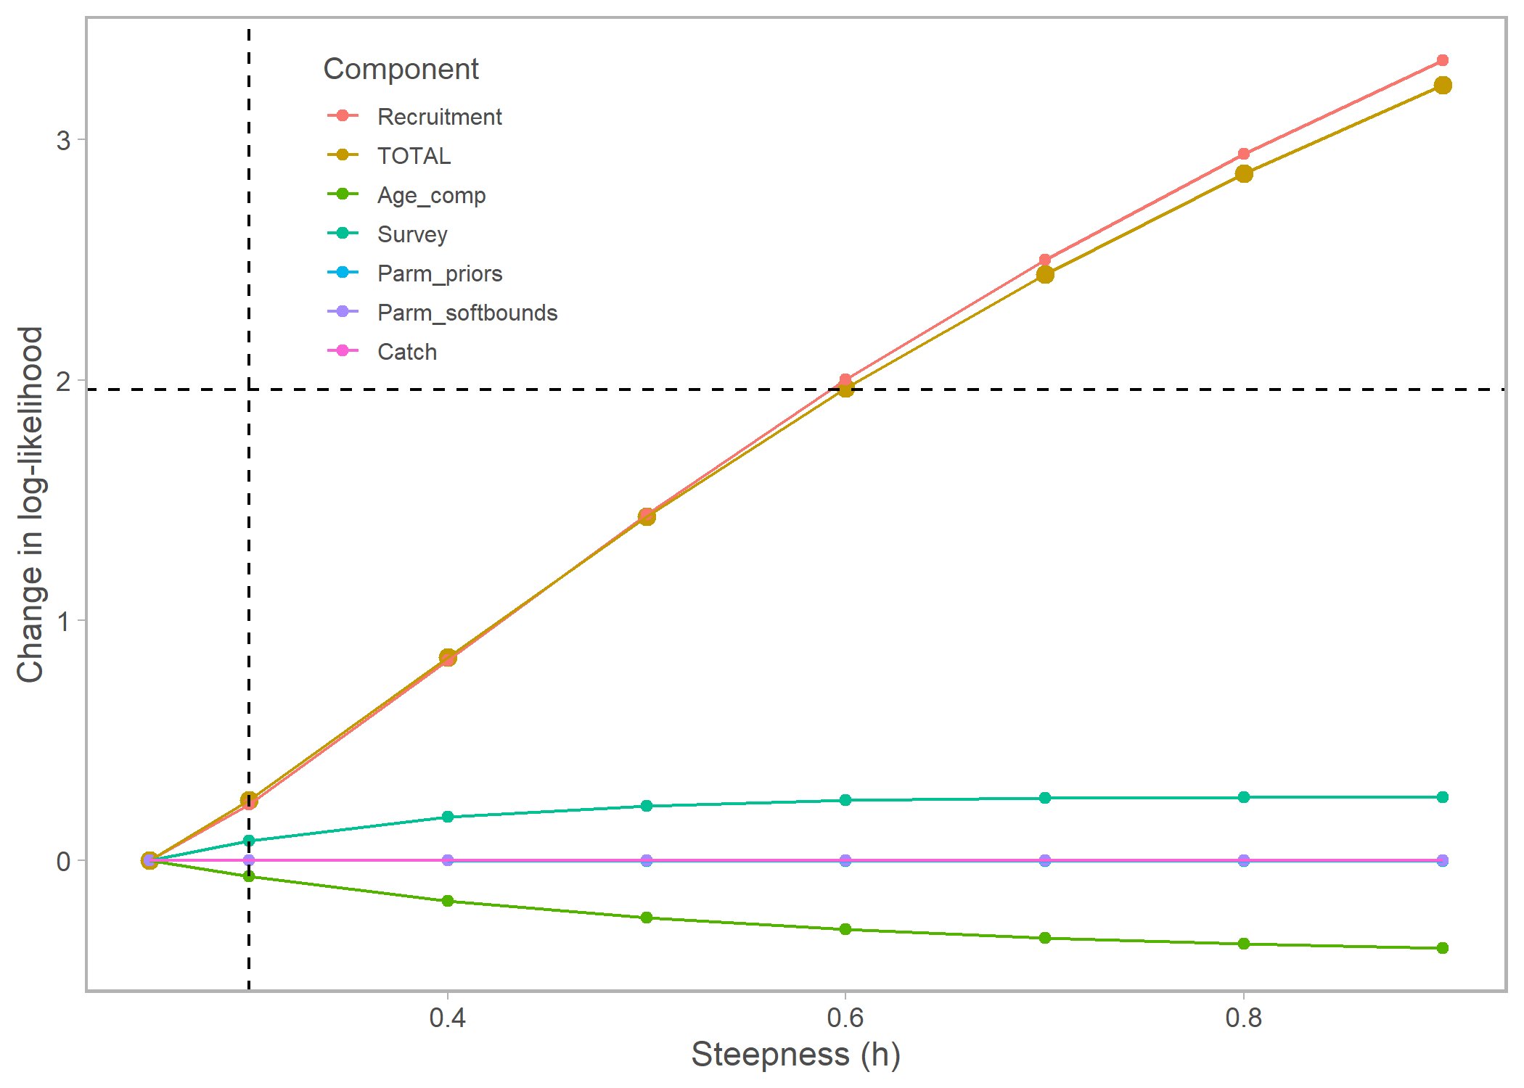

Comparison of the time series of spawning biomass for Big Skate under alternative assumptions about data weighting and recruitment are shown in the figure below ([Taylor et al. 2019](https://www.pcouncil.org/documents/2019/10/status-of-big-skate-beringraja-binoculata-off-the-u-s-pacifc-coast-in-2019-october-2019.pdf/)). The base model used the [Francis (2011)](https://cdnsciencepub.com/doi/abs/10.1139/f2011-025?journalCode=cjfas) method for tuning sample sizes of the age and length compositions.

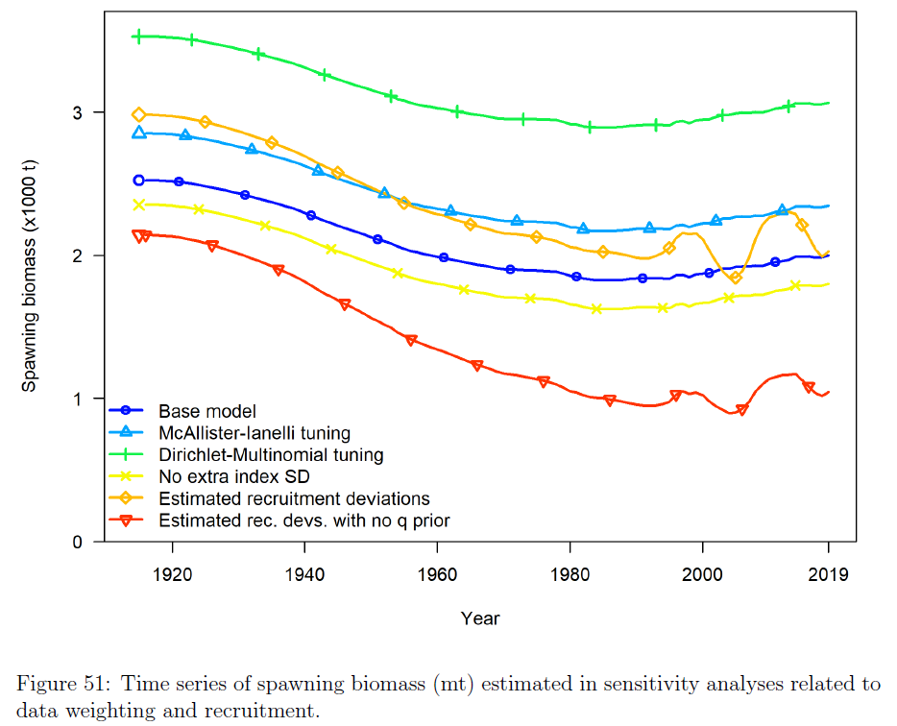

**Recommendations:**

**Key Literature:**

# Age-structured production model [Felipe, name2, …]

**Name**:

**Goal**: The ASPM diagnostic was proposed by Maunder and Piner (2015) to further evaluate model misspecification, and ascertain the influence of composition data on the estimates of trends and absolute abundance. In its essence, the ASPM can be used for assessing whether the catch alone can explain the trends in the indices of abundance.

**Description:** Maunder and Piner proposed an age-structured production model (ASPM) as a model diagnostic for complex age-structured integrated assessments. The ASPM is an integrated age-structured version of a Surplus Production Model. In its simplest form, the ASPM only estimates parameters associated with global scaling and relative scaling using only catch and indices of abundance as data.

**How to:** The ASPM diagnostic is computed as follows: (i) run the fully integrated model; (ii) fix selectivity parameters at the maximum likelihood estimate (MLE) from the fully integrated model, (iii) turn off the estimation of all parameters except the scaling parameters and the parameters representing the initial conditions (a parameter for the equilibrium recruitment and a parameter for the equilibrium fishing mortality), set the recruitment deviates to zero (early recruitment and model period recruitments); (iv) fit the model to the indices of abundance only, and (v) compare the estimated trajectory to the one obtained in the base case.

**What to do:** Suppose the ASPM is able to fit well the indices of abundance that have good contrast (i.e. those that have declining and/or increasing trends). In that case, Maunder and Piner (2015) suggest that this is evidence of a production function's existence, and the indices likely provide information about absolute abundance. They refer to this situation as “the catch explains the indices well”. Subsequently, an ASPM with recruitment deviations estimated (ASPMrec) can be applied to evaluate whether temporal variability in recruitment can be estimated without using size-composition data directly.

If the ASPM shows no good fit to the indices, that is an indication that the catch alone cannot explain the trajectories depicted in the indices of relative abundance. This can have several causes, including the stock is recruitment-driven, or the indices of relative abundance are not proportional to abundance. Checking whether the stock is recruitment-driven involves fitting the ASPMrec. Suppose the ASPMrec cannot capture the population trajectory estimated in the integrated model. In that case, it can be concluded that the information about scale in the integrated model is not coming from the CPUE data and the catches, but rather from the composition data. Composition data provide the best information about recruitment and selectivity, and their influence on the estimation of abundance trends needs to be taken with caution.

**Example (include figures here):** The case study for the ASPM is based on the stock assessment for the North Atlantic shortfin mako shark (SMA; Courtney et al., 2017). Pelagic longline operations catch the vast majority of SMA, but due to strong spatial structuring of size classes, the selectivity pattern differs among the fishing fleets operating in the different regions. The population dynamics of SMA reveal an unusual combination of slow somatic growth, very late maturation, and steep dome-shaped selectivity. The SMA example represents a length-based age- and sex-structured multi-fleet model fit to six standardized CPUE indices. Fisheries-dependent length-composition data are assumed to be representative of the different selectivity patterns for the six major surface longline fishing fleets.

The CPUE trend estimated by the ASPM is very different from those estimated in the fully integrated assessment model. The ASPM diagnostic showed a consistent declining trend over time. The fit to the same index in the fully integrated SMA and ASPMrec models was almost identical and had a more oscillatory pattern (Fig. 1a). The ASPM can estimate the “correct” scale of the biomass only when recruitments are allowed to vary (Fig. 1b). Results from the ASPMrec indicated that the CPUE data and the catches contained information on temporal variability on recruitment (Fig 1c).

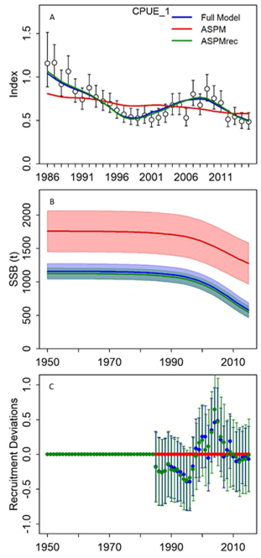

Fig. 1. Comparison between the fully integrated base-case and the deterministic Age-Structured-Production Model (ASPM) model results for North Atlantic shortfin mako (SMA).

**Recommendations:** Any stock assessment must find the relationship between fishing and changes in abundance. The ASPM is easier to produce in software packages like Stock Synthesis, and its implementation should be encouraged while building a complicated assessment model.

**Key Literature:**

Courtney, D., Cortes, E., Zhang, X., 2017. Stock Synthesis (SS3) model runs conducted for North Atlantic shortfin mako. Collect. Vol. Sci. Pap. -ICCAT 74, 1759–1821.

Maunder, M.N., Piner, K.R., 2015. Contemporary fisheries stock assessment: many issues still remain. ICES J. Mar. Sci. 72, 7–18.

Minte-Vera, C. V., Maunder, M.N., Aires-da-Silva, A.M., Satoh, K., Uosaki, K., 2017. Get the biology right, or use size-composition data at your own risk. Fish. Res. 192, 114–125.